 



Database Programming with SQL 19-1: Testing

Practice Activities

# Objectives

* Develop and apply a strategy for testing that a database functions as designed.

# Try It / Solve It

1. Design and carry out tests to check the following:
   1. The business rule that requires that employees have a job_id

INSERT INTO employees(employee_id,first_name,last_name,email,phone_number,hire_date,job_id,salary,commission_pct,manager_id,department_id)

VALUES(300,'Hemant','Kumar','HKUMAR',NULL,TO_DATE('2016-11-16','yyyy-mm-dd'),NULL,17000,null,100,90 );

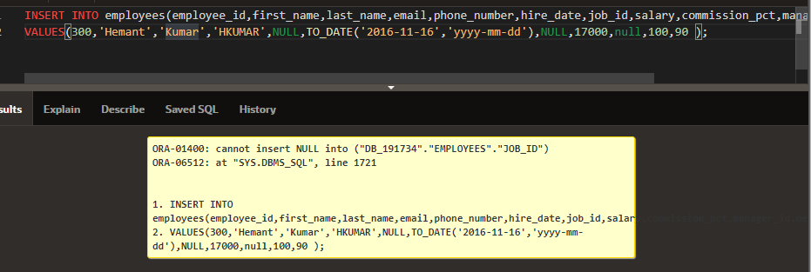

* 1. The business rule that requires that the end date of an employment is after a start date in the job history table.

INSERT INTO job_history(employee_id,start_date,end_date,job_id,department_id)

VALUES(102,TO_DATE('11-15-2016','mm-dd-yyyy'),TO_DATE('06-17-1993','mm-dd-yyyy'),'AD_ASST',90 );

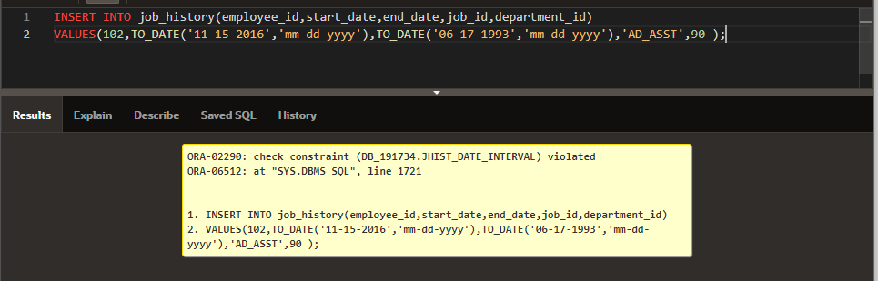

* 1. The business rule that states that departments can be closed down with employees in that department (resulting in the department_id becoming unknown).

DELETE FROM departments WHERE department_id = 10;

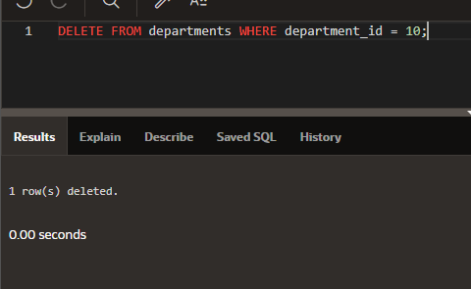

select department_id from employees WHERE department_id not in ( select nvl(department_id , 0) from job_history);

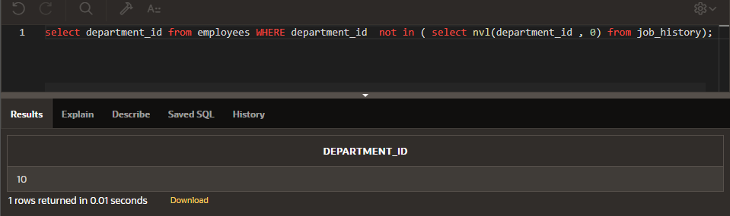

* 1. The minimum salary of an employee is 1000.

UPDATE employees

SET salary = NULL

WHERE employee_id = 144;

UPDATE employees

SET salary = 1999

WHERE employee_id = 144;

CONSTRAINT "EMP_SALARY_MIN" CHECK (salary > 1000) ENABLE

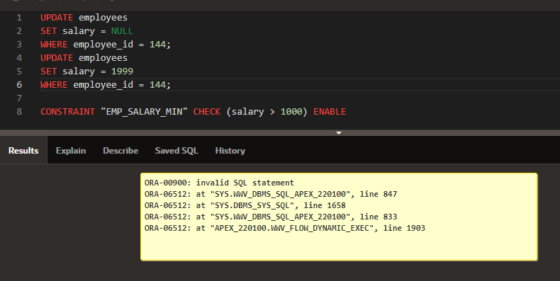

1. If one of the above tests fails, write out the SQL statement(s) that would be needed to correct the test. With the permission of your teacher, implement the change and then rerun the test with the same input and confirm that it works.

ALTER TABLE employees

MODIFY salary CONSTRAINT emp_salary_nn NOT NULL;

ALTER TABLE employees

DROP CONSTRAINT emp_salary_min;

UPDATE employees

SET salary = 1000 WHERE NVL(salary,0) < 1000;

ALTER TABLE employees

ADD CONSTRAINT emp_salary_min CHECK (salary >= 1000);

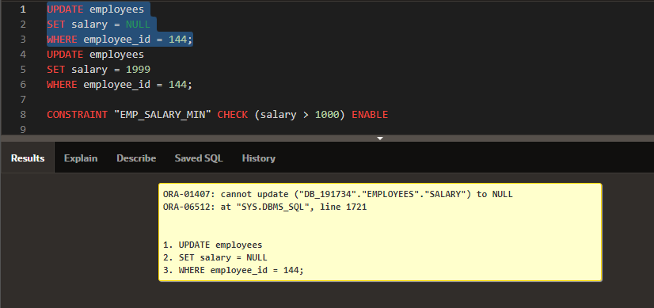

Copyright © 2020, Oracle and/or its affiliates. All rights reserved. Oracle and Java are registered trademarks of Oracle and/or its affiliates. Other names may be trademarks of their respective owners.